4.3 Solution Architecture
The source project document provides the ComicCraft solution architecture, showing the relationship between the user interface, FastAPI backend, AI generation components, image generation, layout processing and PDF export.
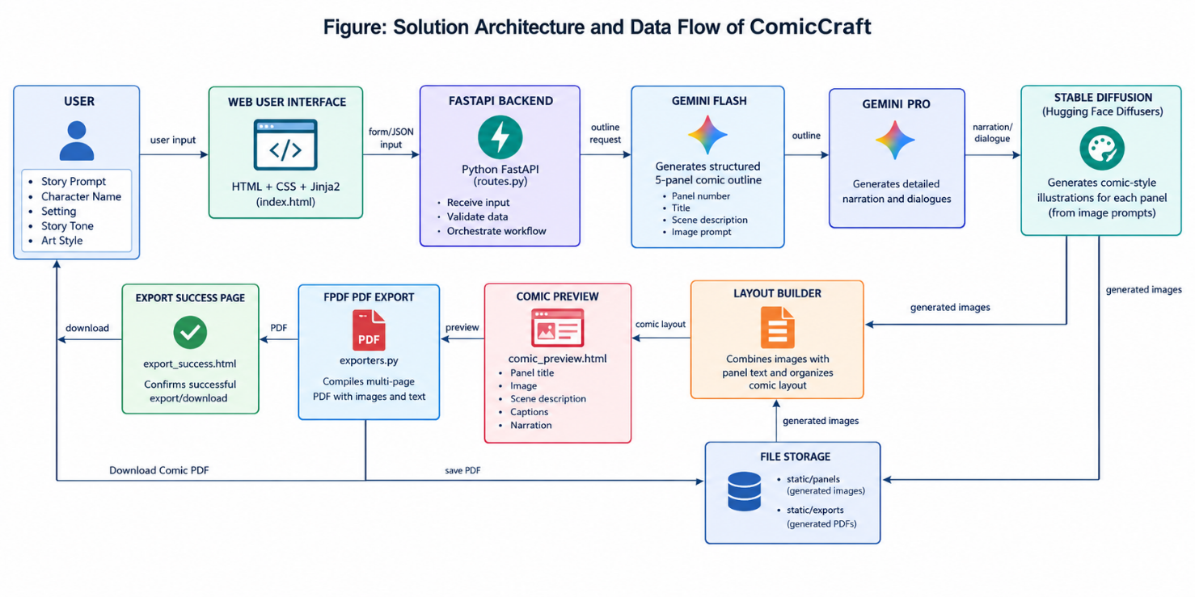
ComicCraft Solution Architecture

